

**CIS 11042 – Practical for Essential of ICT and PC Applications**

Information and communication Technology

Faculty of Technology

South Eastern University of Sri Lanka

Registration Number: SEU/IS/22/ICT/075

Academic year: 22/23

Date: 06.03.2025

Lab Sheet 03

**Exercise 01**

**1.** Opening a new blank document. 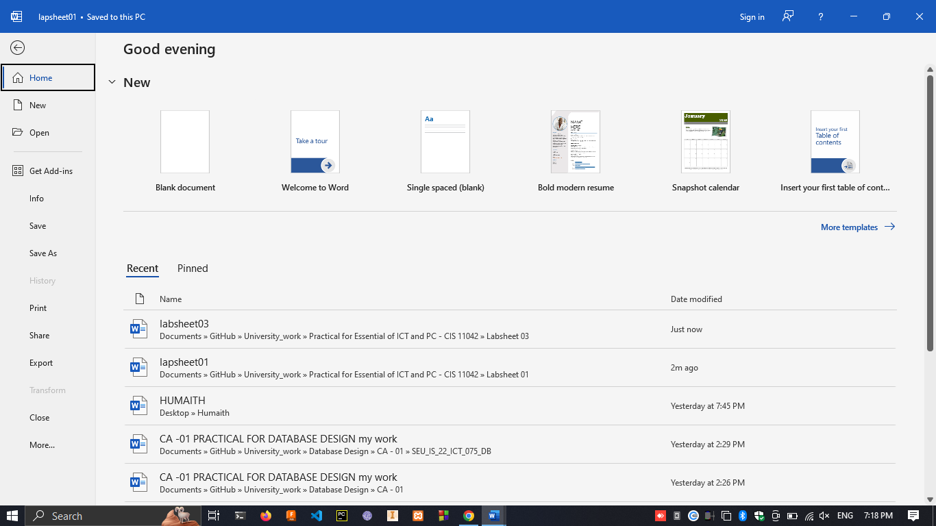

**2.** Typing the paragraph 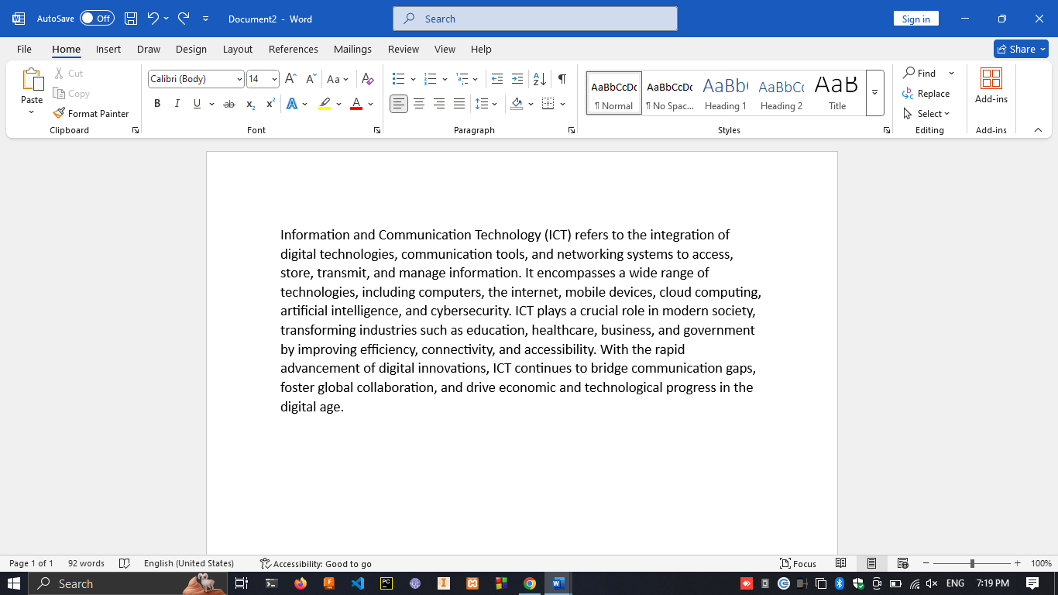

1.

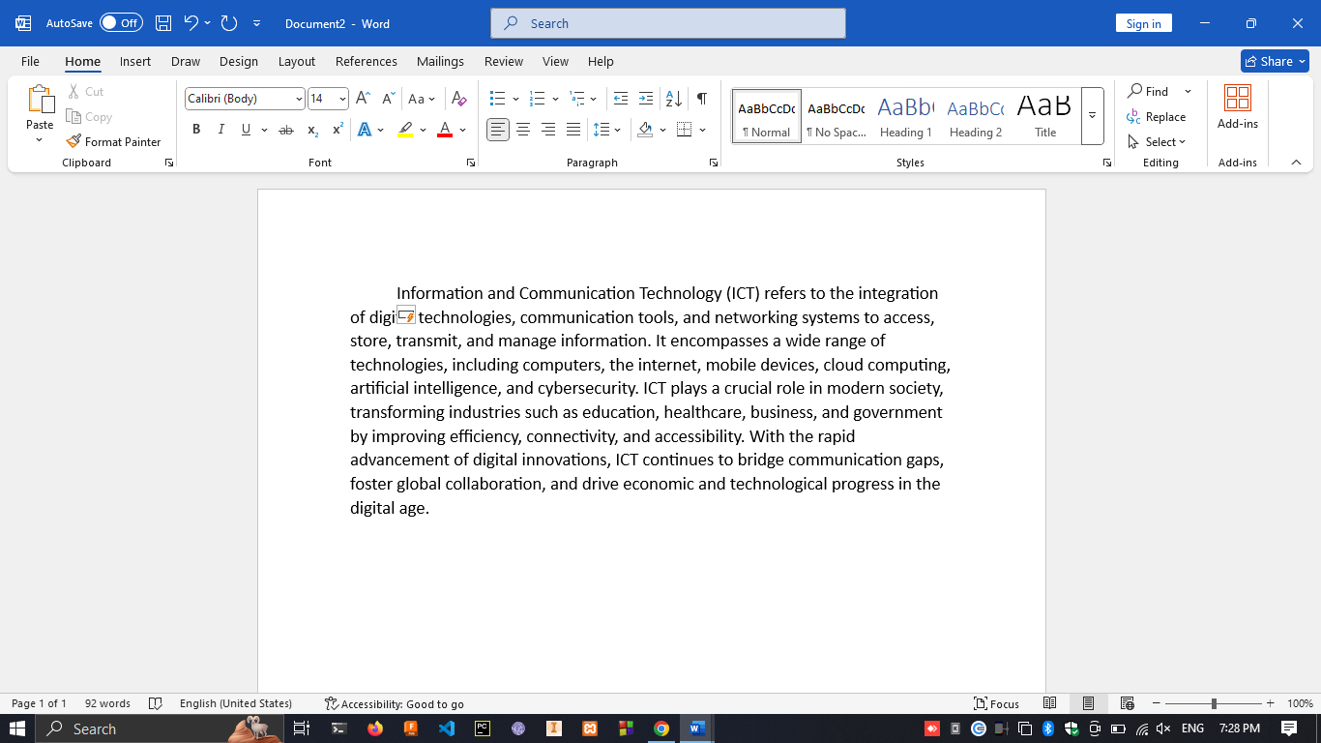

1. Using the indent command in the tool bar.



1. Open word -> Design -> Paragraph Spacing

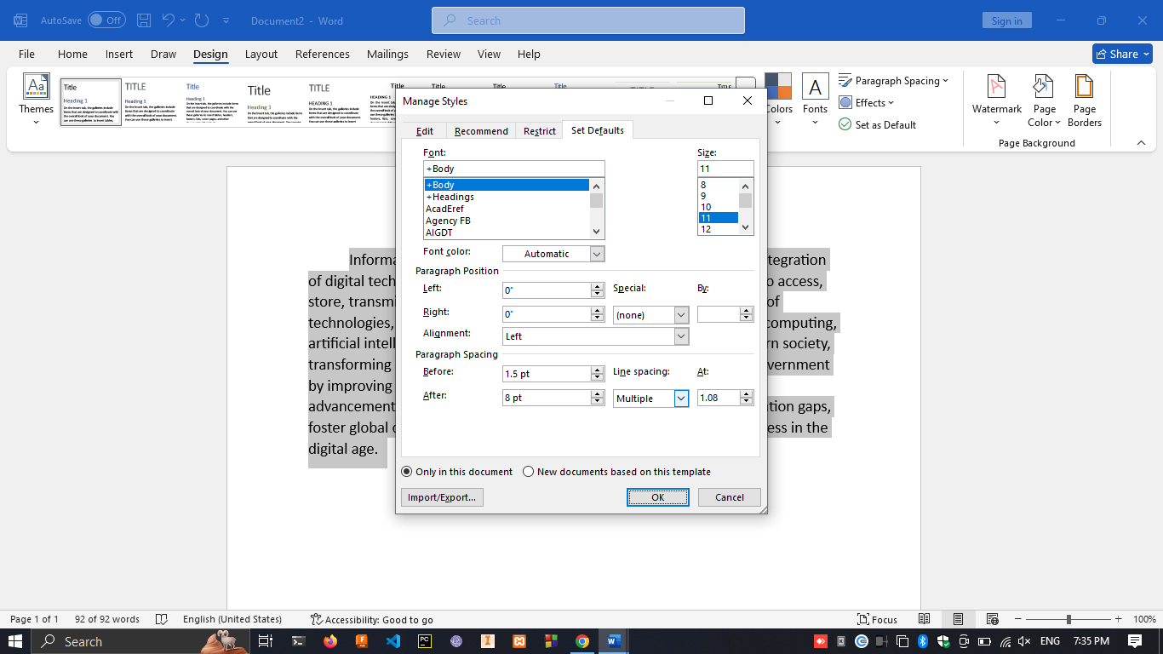

1. Layout tab -> spacing section -> setting before as 6pt after as 12pt

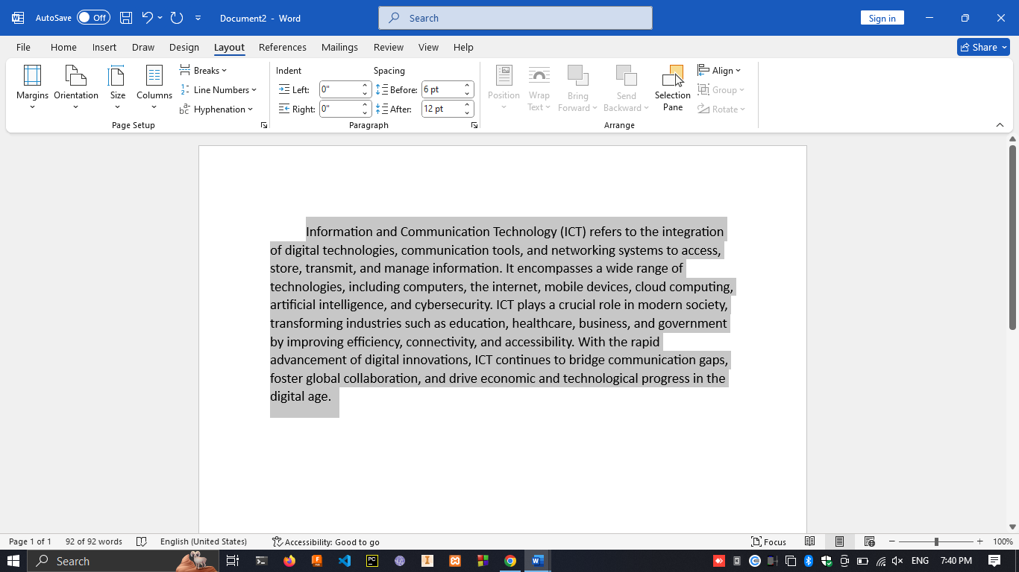

1. Home tab -> click on bullet list button

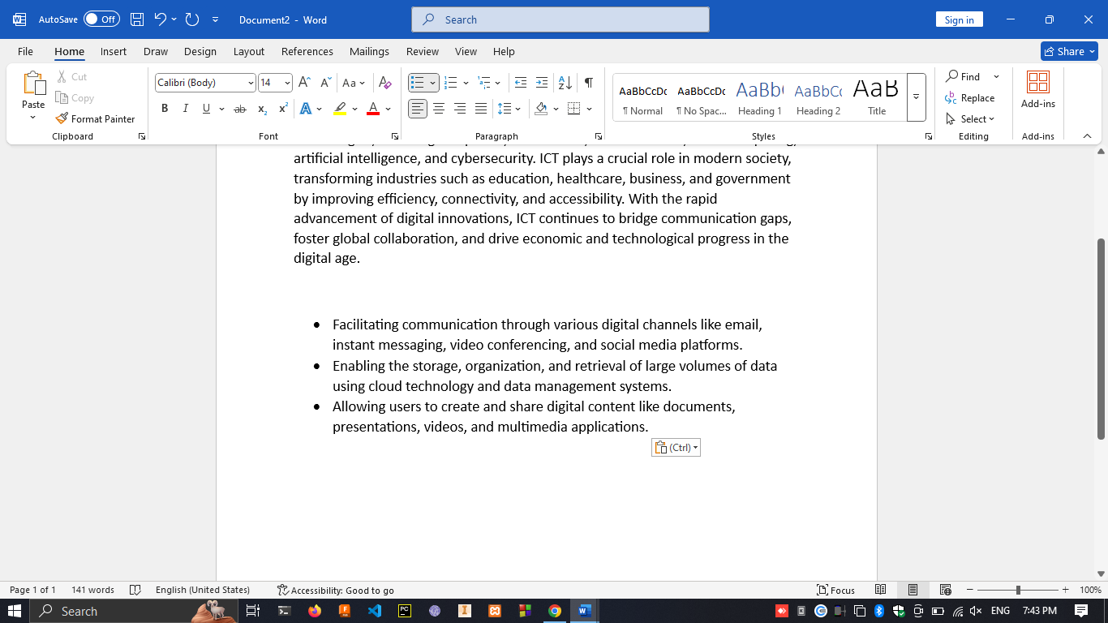

1. While selected on bullet list click on numbering list button

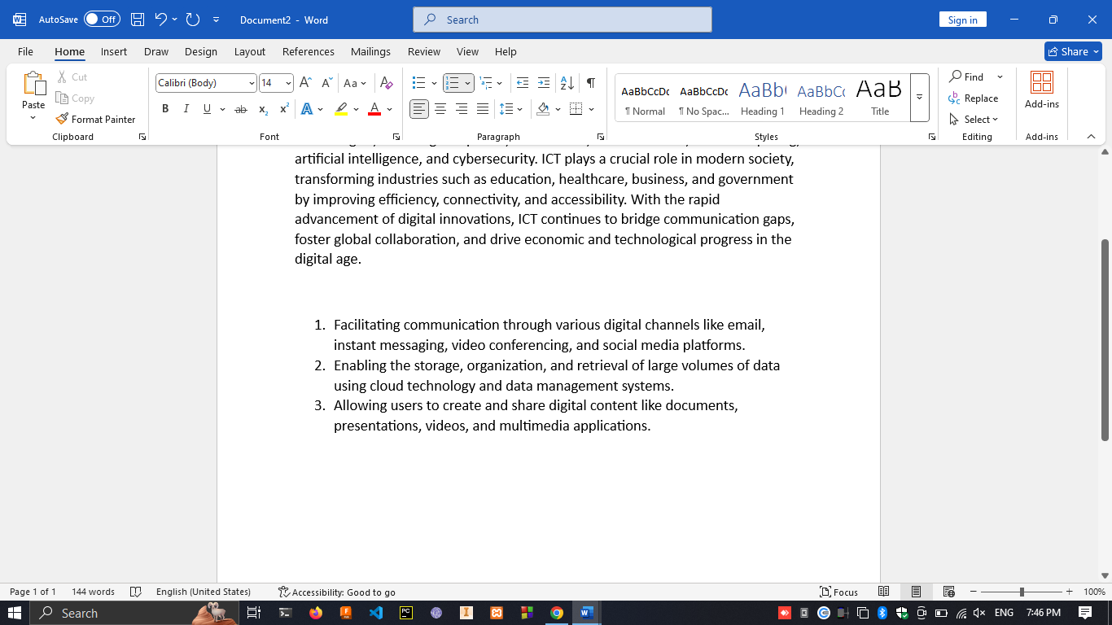

**Exercise 02**

1. Opening the new word document by clicking **blank Document**  and typing following text



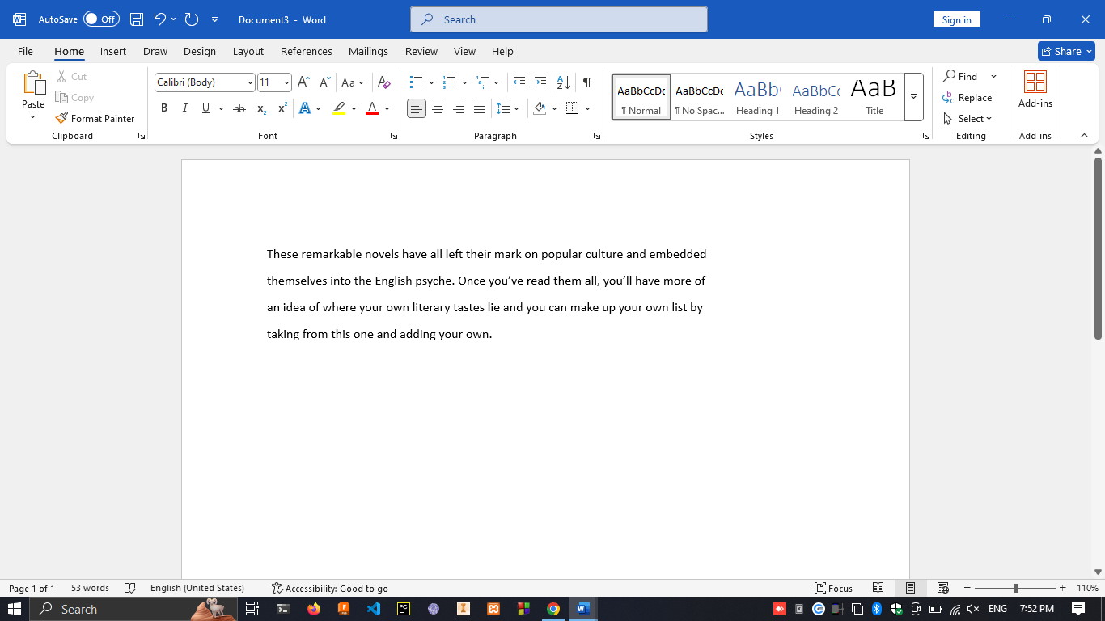

2. Press **ctrl + f** -> type “your own”

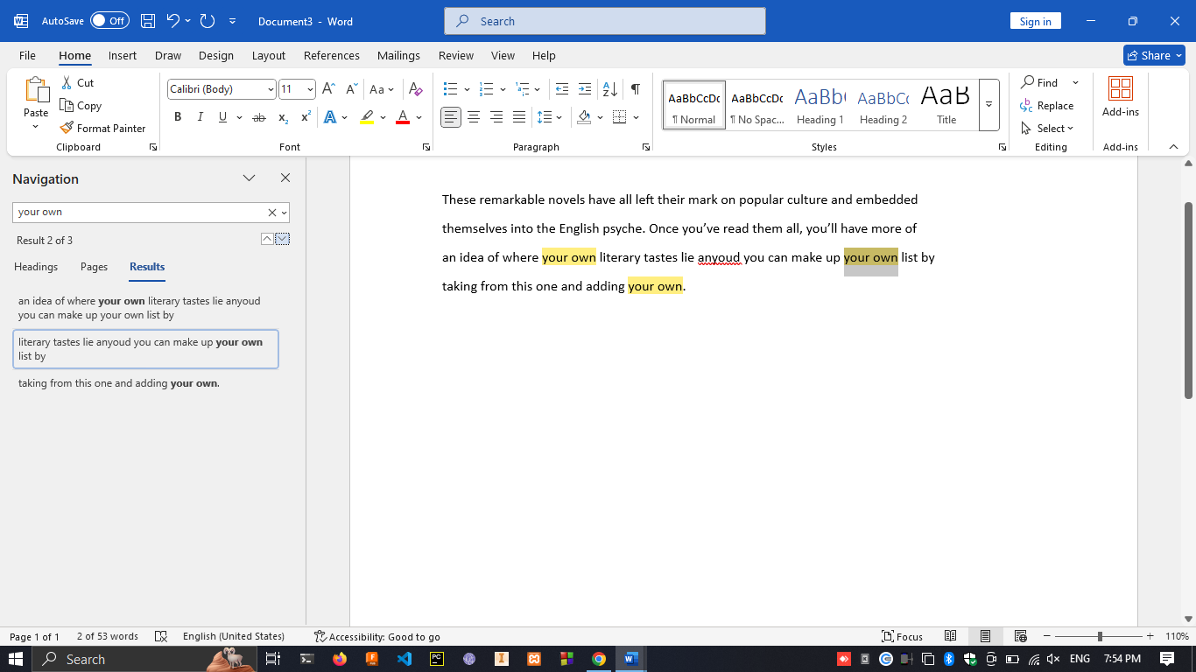

1. Click on **Replace**  under in editing type in Home tab > type “your own” in Find what and “your” in Replace with and click replace all.

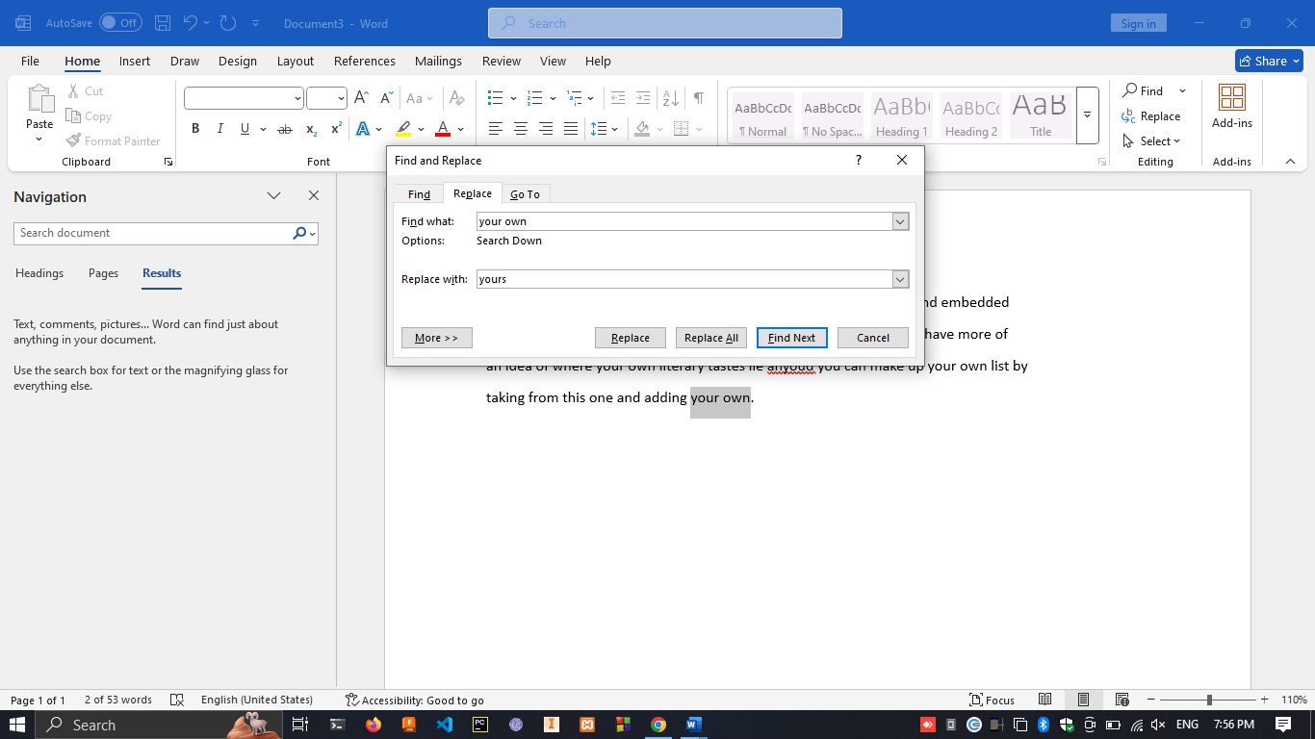

1. Select **Home**  word in text document -> in insert tab click on **Link** -> under the address pasting this link “https://en.wikipedia.org/wiki/English_language”.

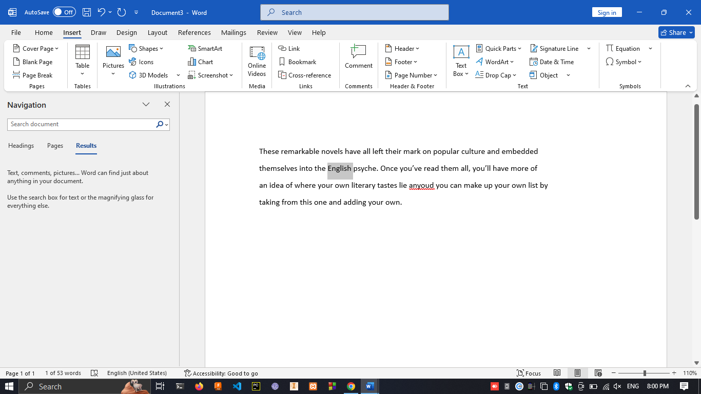

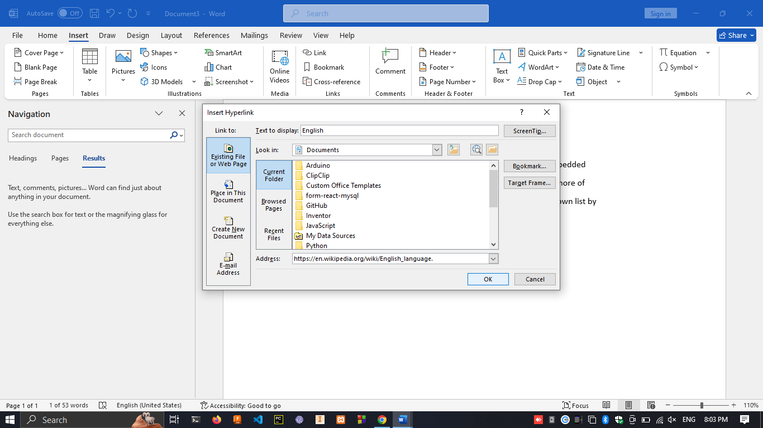

1. Right click on the hyperlink -> click on edit hyperlink -> under the address bar replace the link with **https://learnenglish.britishcouncil.org**

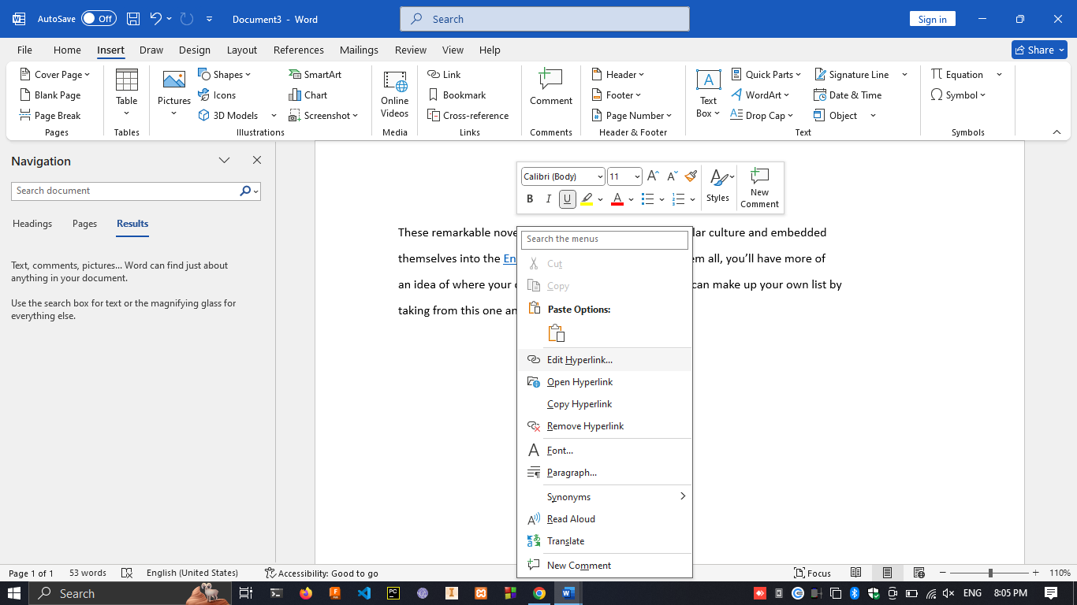

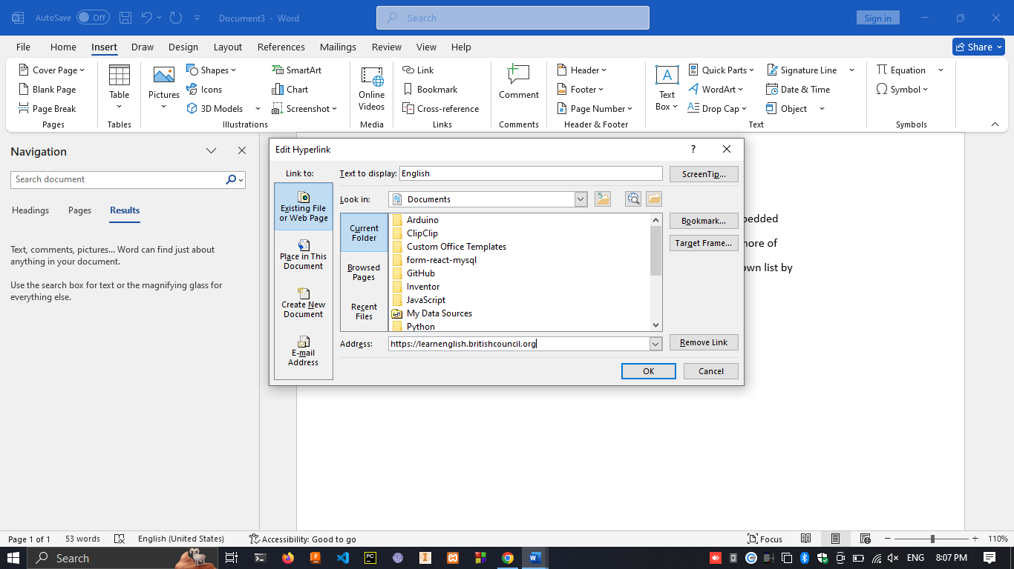

1. Removing the hyperlink by right clicking on the English word click on **Remove hyperlink.**

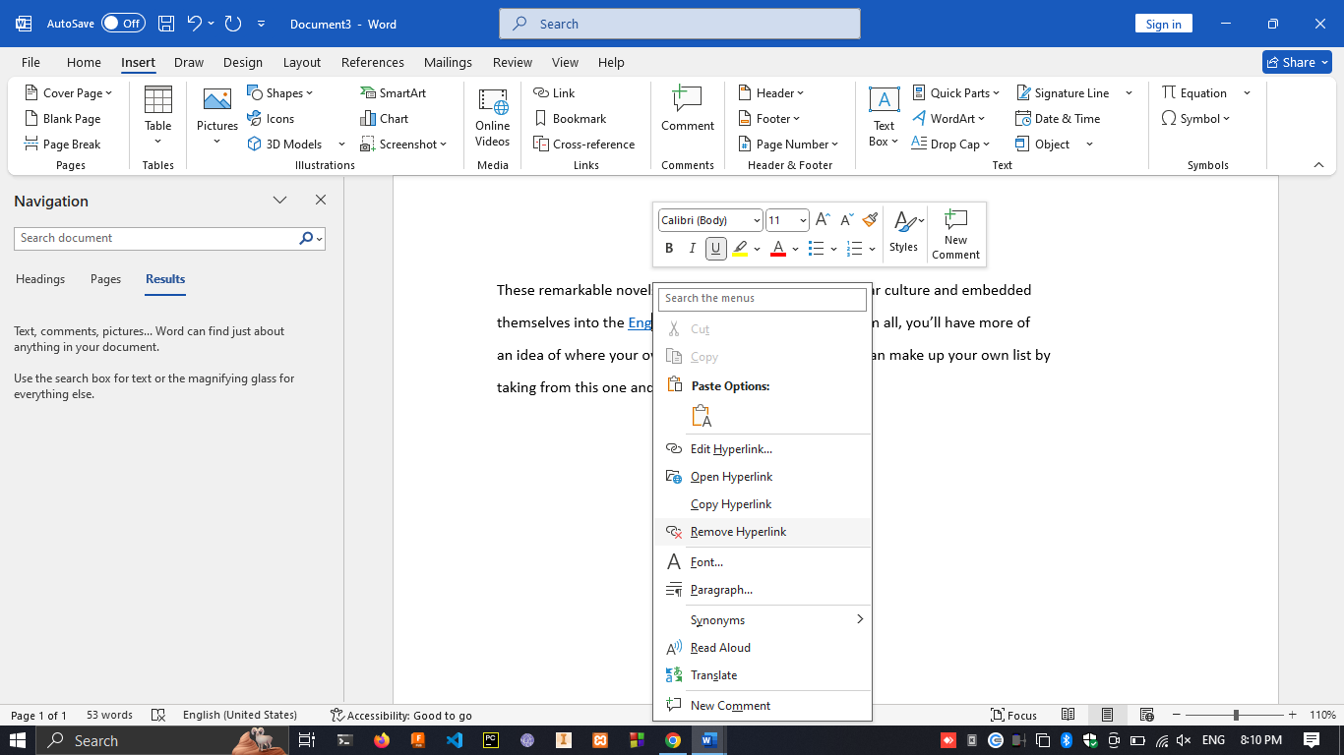

**Exercise 03**

1. Open new work document by click on blank document -> under the layout tab -> click on Orientation -> click on landscape.

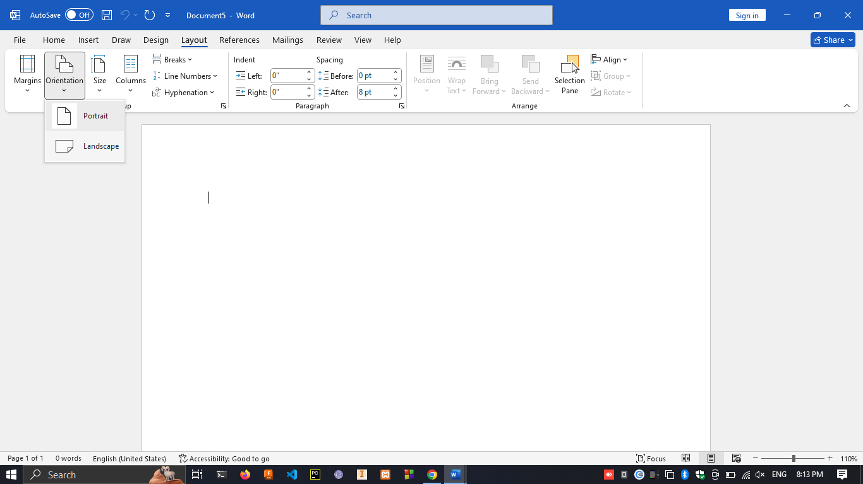

1. Right next to Orientation click on size -> click on A3.

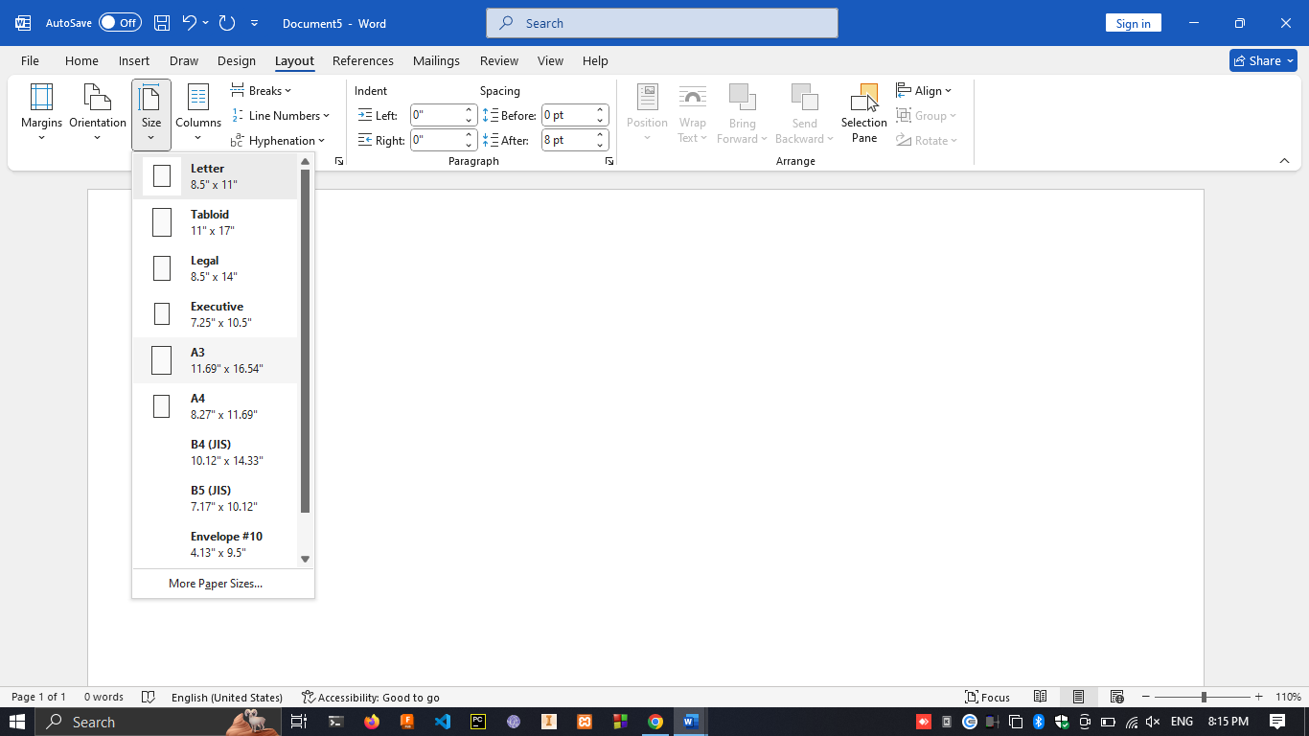

1. right next to Orientation click on margins -> click on narrow

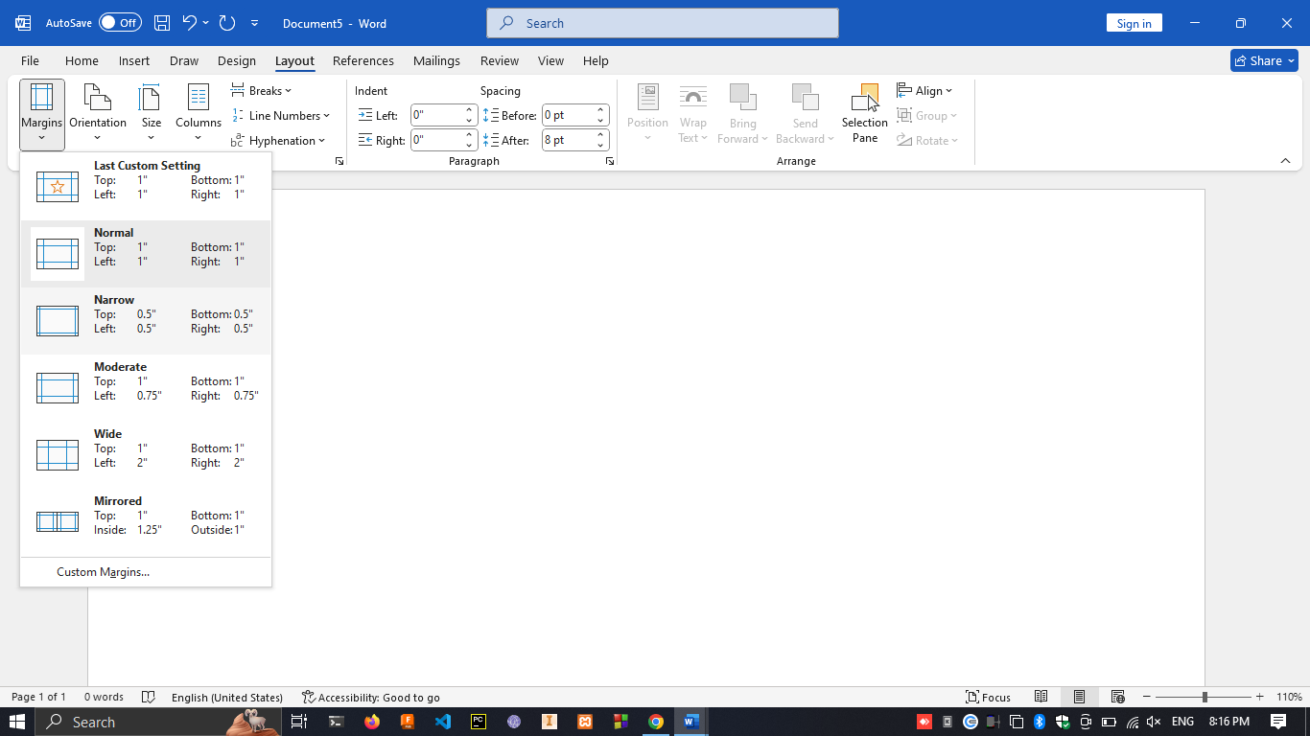

1. click on **multilevel list** in paragraph section under home. -> define new multilevel list

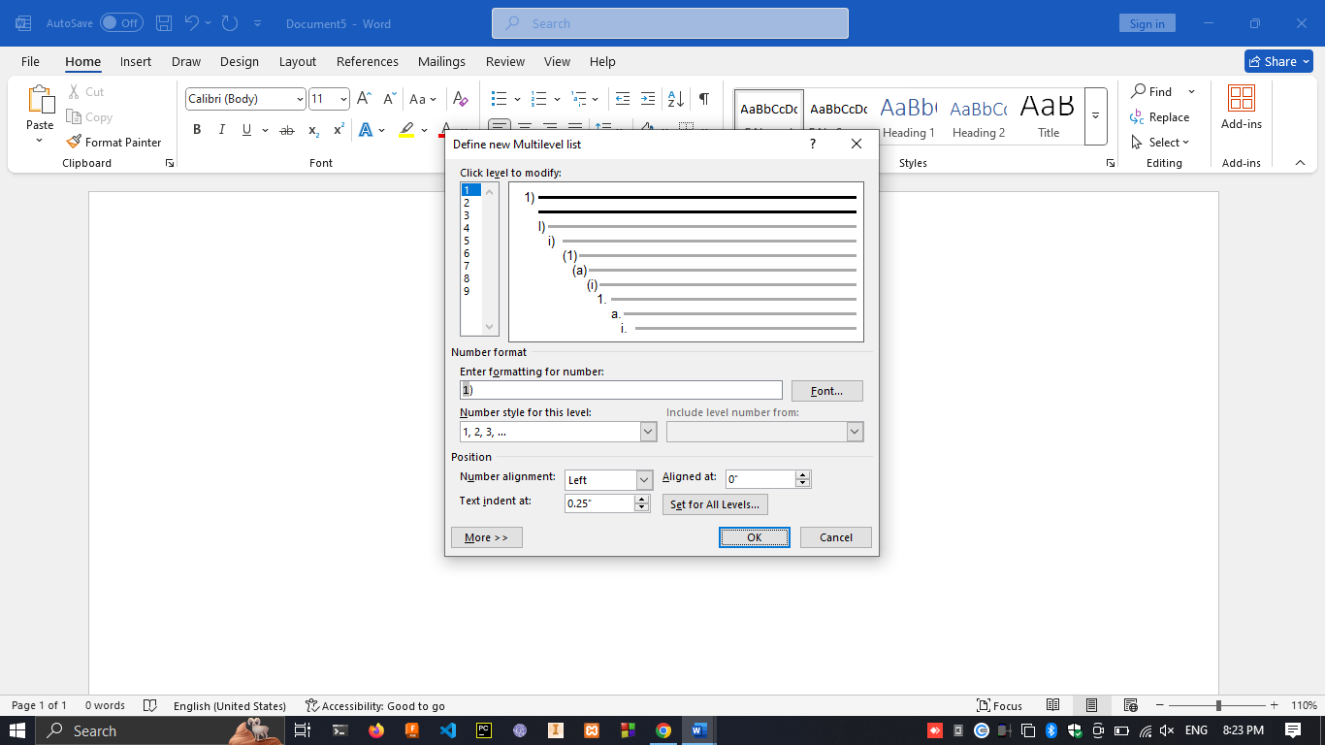

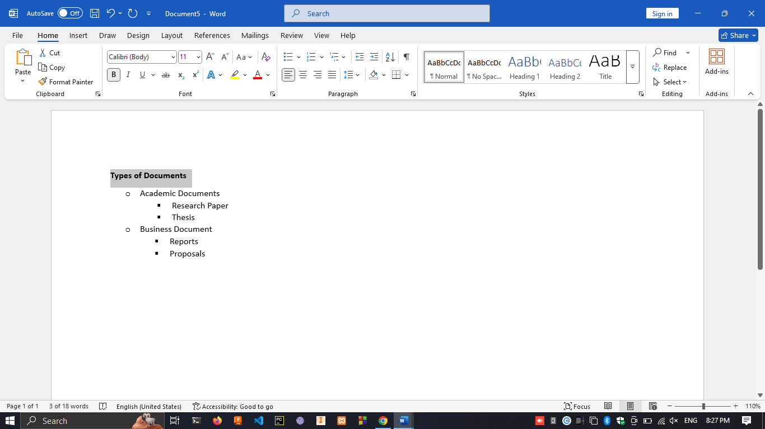

1. under the home tab click on increase indent under the paragraph.

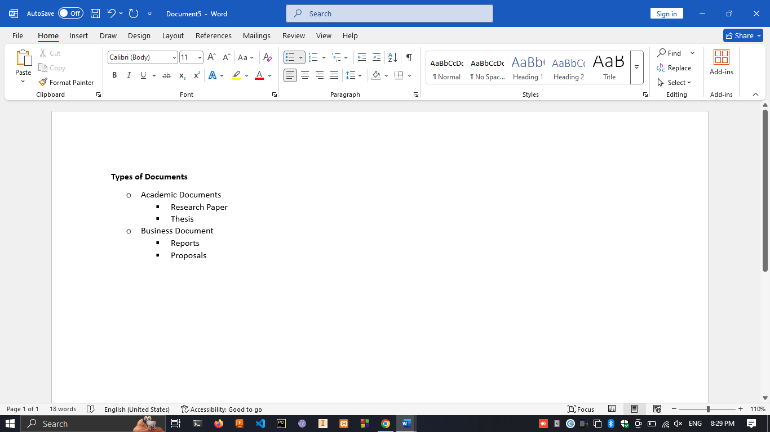

1. next to **Increase indent** click **Decrease indent**

